Patrick Griffin

4/8/17

Class Participation #5

***…instructions.cpp***

Output for instructions.cpp

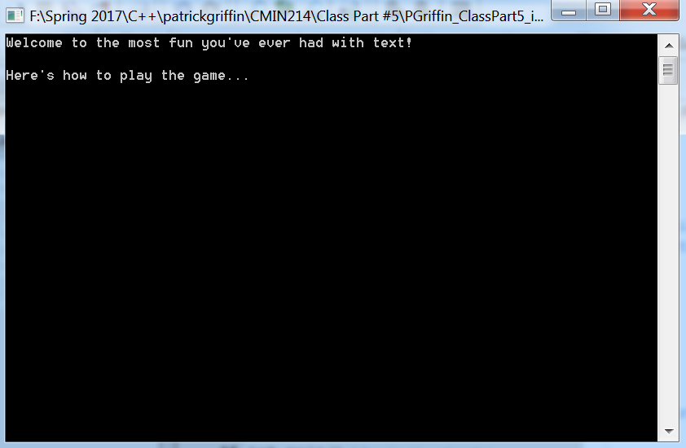

***…yes_or_no.cpp***

Output for …yes_or_no.cpp

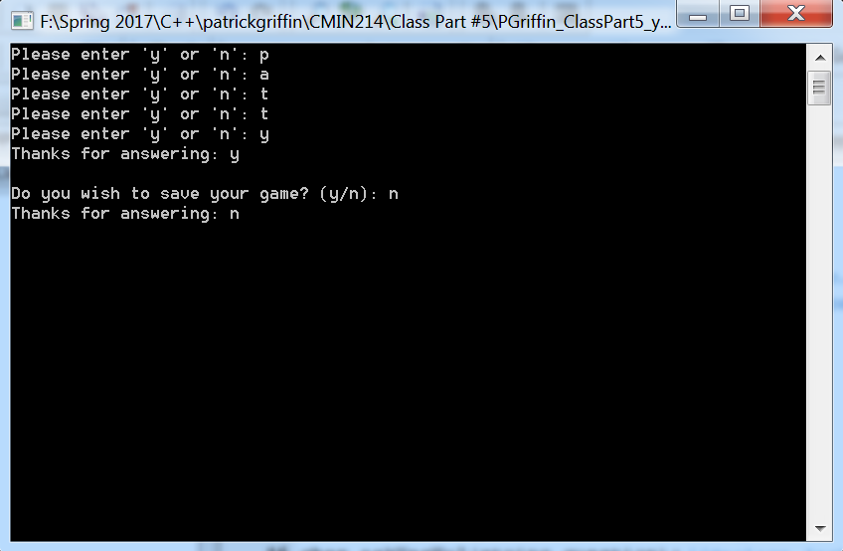

***…taking_damage.cpp***

Output for …taking_damage.cpp

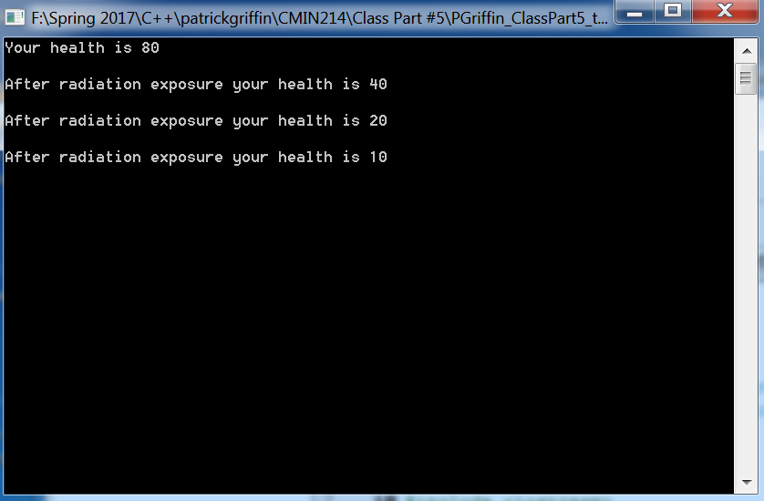

***…give_me_a_number.cpp***

Output for give_me_a_number.cpp

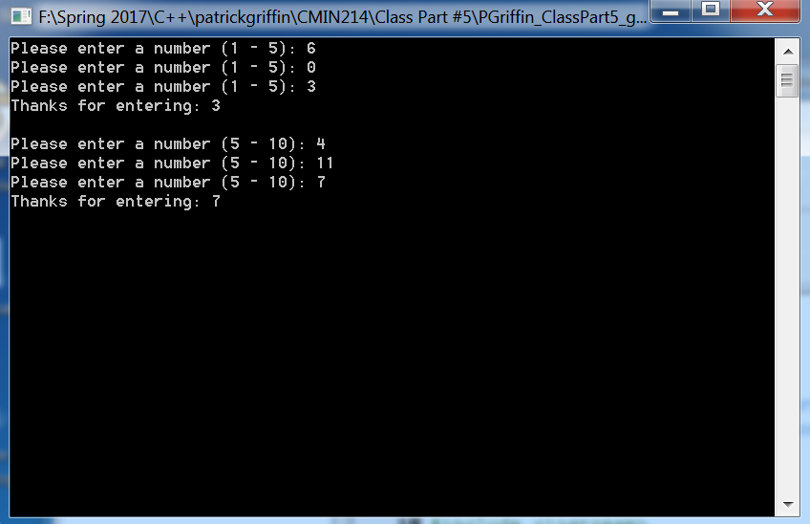

***…give_me_a_number2.0.cpp***

Output for give_me_a_number2.0.cpp

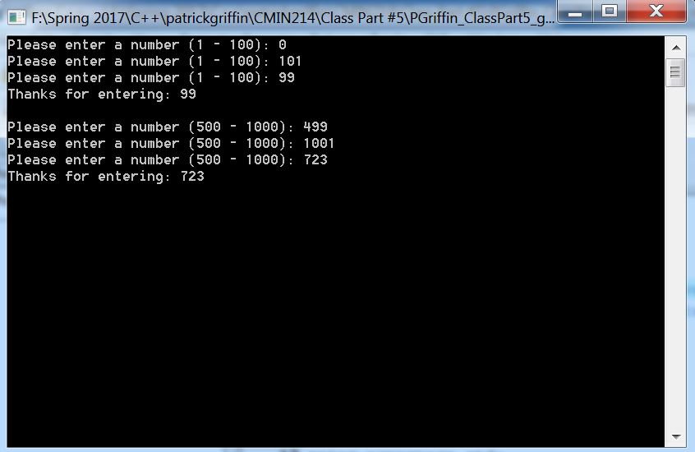

***…give_me_a_number3.0.cpp***

Output for give_me_a_number3.0.cpp

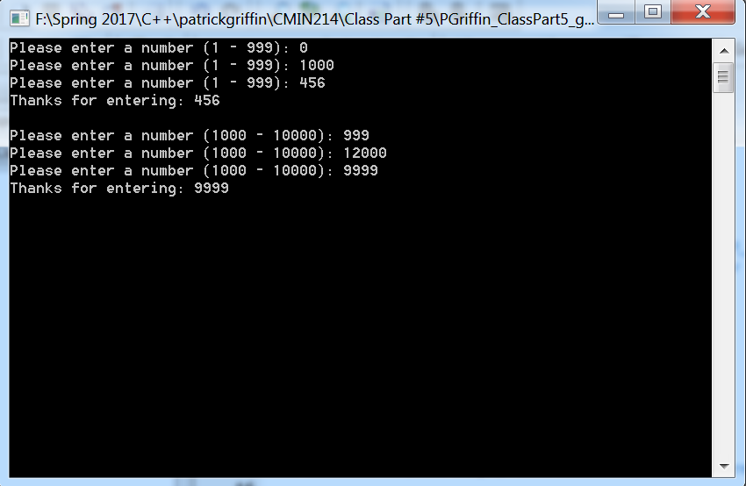

***…give_me_a_number4.0.cpp***

Output for give_me_a_number4.0.cpp

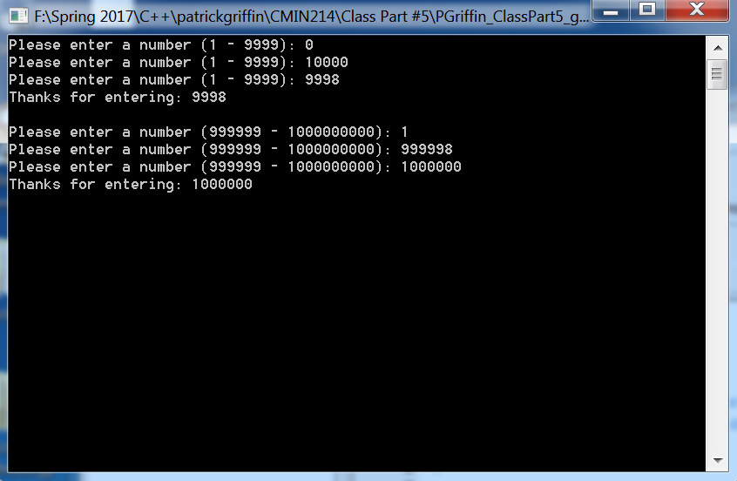

***…mad-lib.cpp***

Output for …mad-lib.cpp

